🛡️ **Cyber Defense Suite**

Cyber Defense Suite is an allinone cybersecurity threat detection and analysis platform that integrates multiple security modules to provide a unified defense mechanism against modern cyber threats. It is designed for network monitoring, hostbased detection, log anomaly analysis, and phishing/malicious URL detection, making it a comprehensive solution for organizations, researchers, and students in the cybersecurity field.

**🚀 Features**

🌐 Network Threat Detection – Detect port scans, DDoS attempts, and malicious traffic in realtime.

💻 HostBased Monitoring – Track suspicious processes, unauthorized file changes, and malware using hashbased detection.

📊 Log Anomaly Detection – Analyze firewall/system logs with rulebased, statistical, and behavioral techniques.

🔗 Phishing & URL Detection – Identify malicious or phishing links to prevent social engineering attacks.

📑 Report Generation – Generate detailed forensic reports with severity levels and timelines.

🎛 Web Dashboard – Flaskbased interface with realtime monitoring and visualization.

🛠️ Tech Stack

* Backend: Python (Flask)
* Frontend: HTML, CSS, JavaScript
* Libraries/Tools: Scapy, psutil, hashlib, pandas, matplotlib

📥 Installation

1. Clone this repository:

“bash”

git clone https://github.com/yourusername/cyberdefensesuite.git

1. cd cyberdefensesuite
2. Install dependencies:

pip install r requirements.txt

1. Run the application:

python app.py

1. Open in browser:

<http://127.0.0.1:5000>

**📸 Screenshots**

**Dashboard**

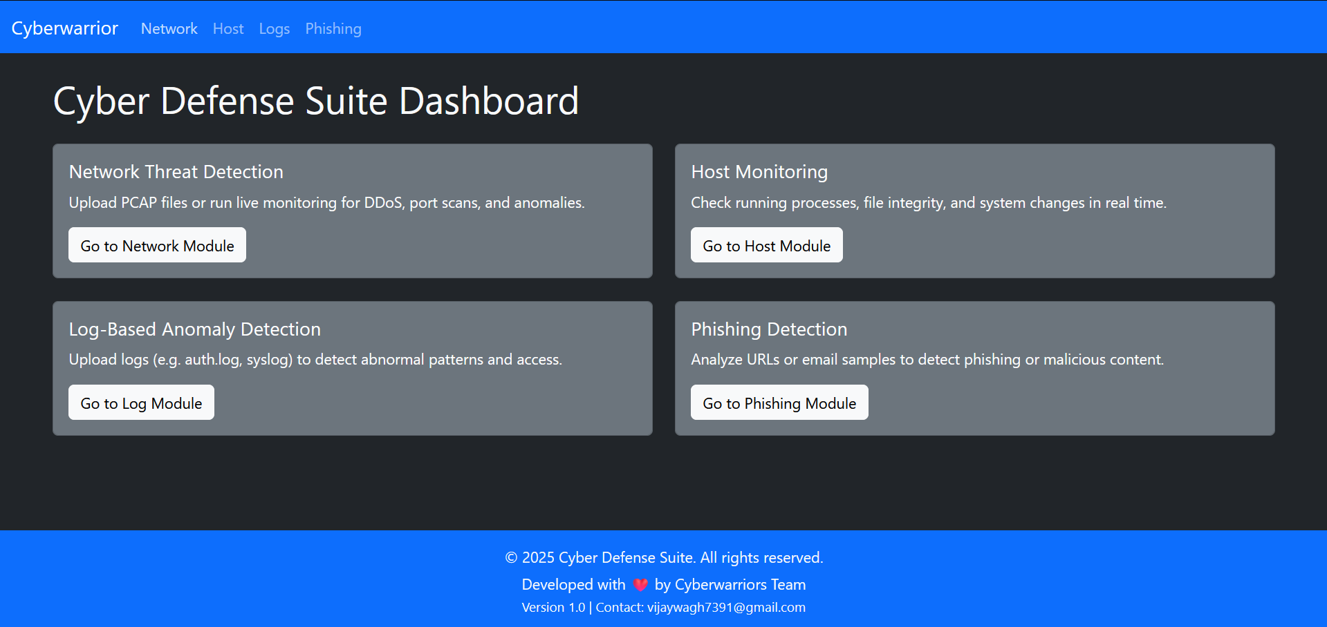

**Network Threat Detection**

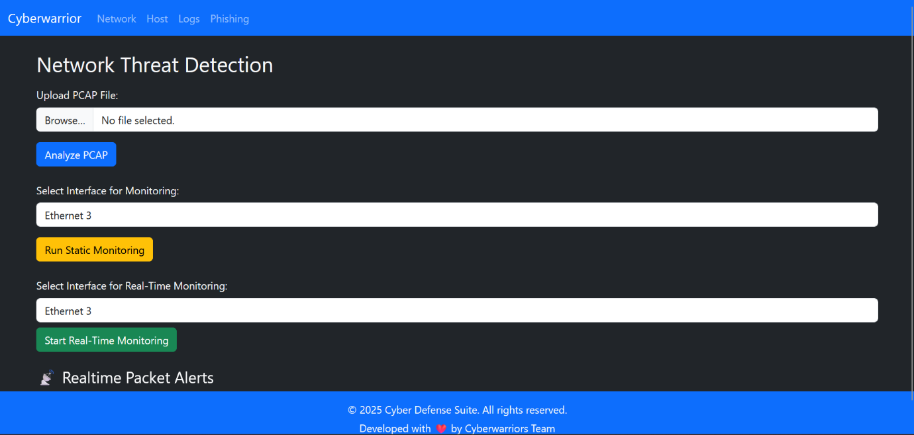

**Host-based Threat Detection**

**Log-Based Anomaly Detection**

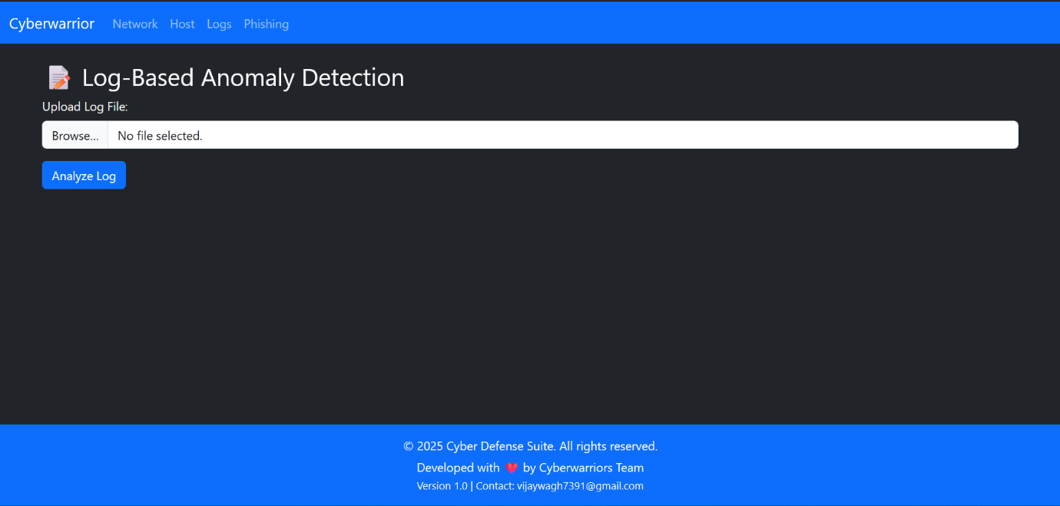

**Phishing and Malicious URL/Email Detection**

**📌 Use Cases**

* Security Operations Centers (SOC)
* Academic & research projects in cybersecurity
* Businesses seeking affordable monitoring solutions
* Students building cybersecurity portfolios

**📜 License**

This project is licensed under the **MIT License** – you are free to use, modify, and distribute.

**👨‍💻 Author**

Developed by [**Cyberwarrior**](https://github.com/your-username)

Copyright © 2025 Cyberwarrior. All rights reserved.